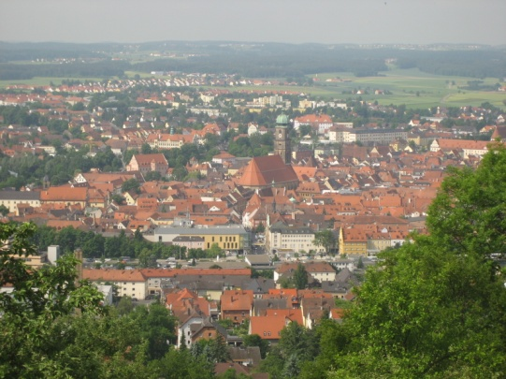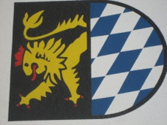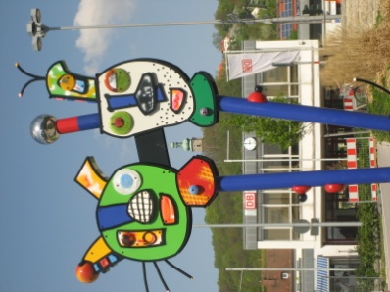
Experience Amberg
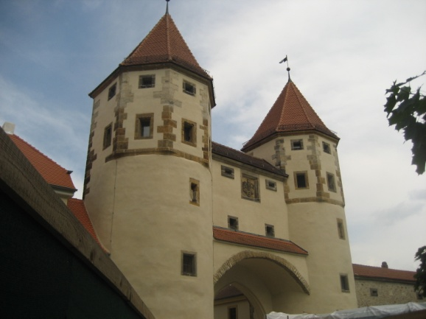 | 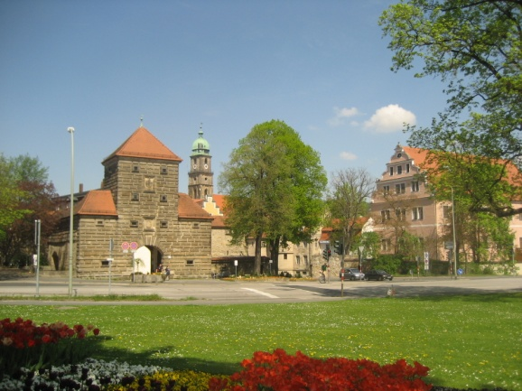 | 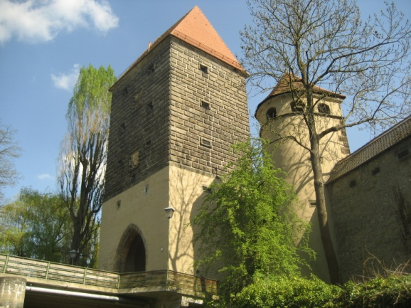
The construction of Amberg’s FORTIFICATION began in 1326. Its oval shape is called the “egg”.

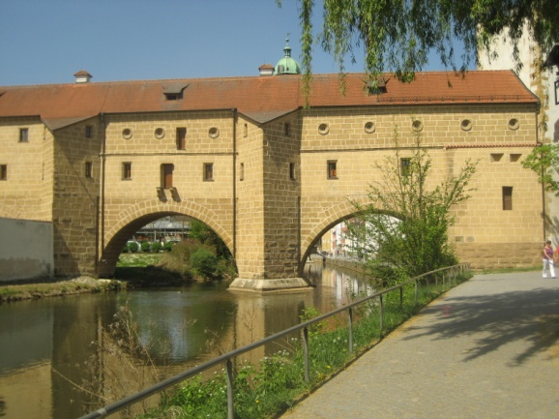 | TOWN GLASSES  The gatebridge over the River Vils was built in 1454. It is called the town spectacles because the two arches are reflected in the water.  CITY WALLS | 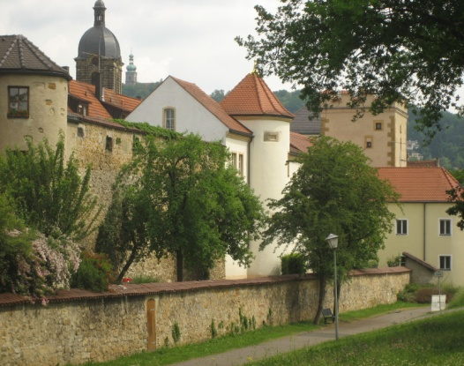
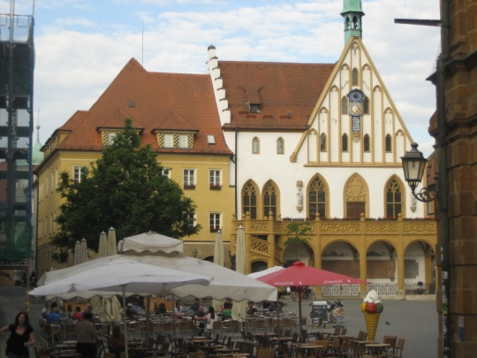 | Town hall, marketplace and  St. Martin’s form the political, economic and religious centre.  TOWN HALL  The former hall chapel was first mentioned in 1348 and radically redesigned in the 19th century.  ST. MARTINS  St. Martin’s is the biggest hall church in North Bavaria. | 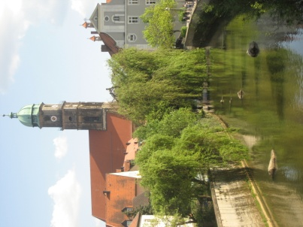
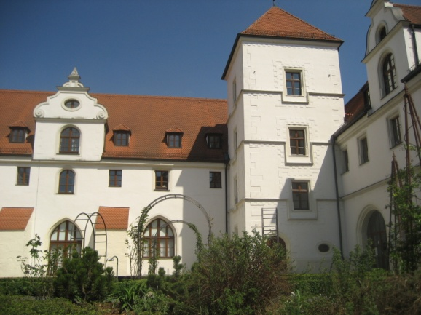 | ARMORY  The former armory, built by Prince Elector Philip around 1502, is now an administrative building for the district of Amberg-Sulzbach.  ELECTORAL PALACE  It was built in 1417 and used as a residence by the Prince Electoral. It serves as an administrative building as well. | 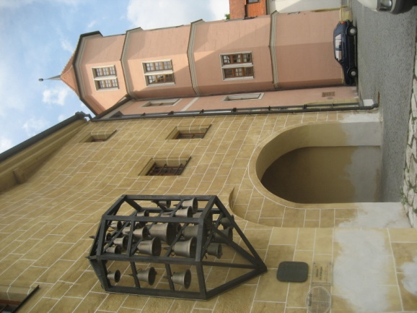
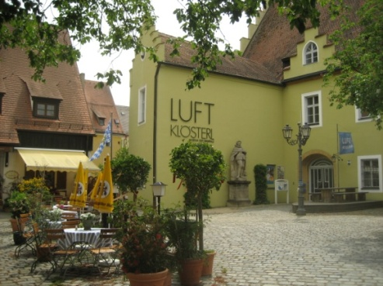 | 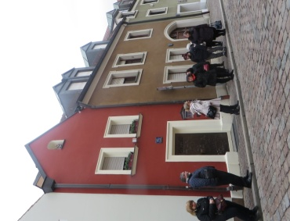 | 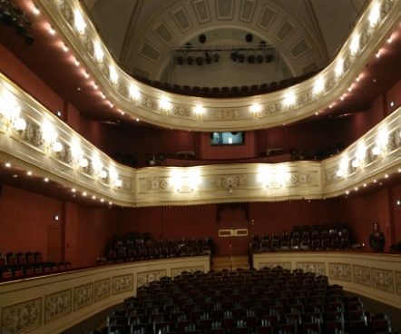
AIR MUSEUM  The only air museum in the world offers exhibits on art, archi-tecture and technology that all relate to the air. | EH’HÄUSL  Its story is portrayed on the frontdoor. When a couple wanted to marry in the Middle Ages, they had to own a house in the city to get the permission of the magistrate. The owners changed rapidly and many couples could marry. Today it’s a luxury hotel for two persons only. | TOWN THEATRE  The Franciscan monastery was built in 1452. After the secularization it became the Town Theatre. It was completely refurbished in the 1970s.
Some of Amberg’s magnificient CHURCHES.

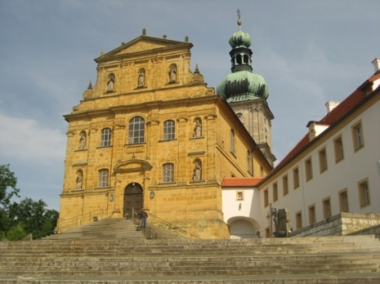 | 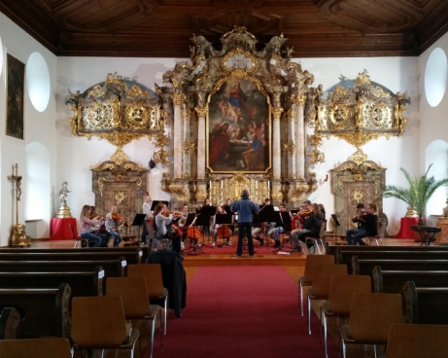 | 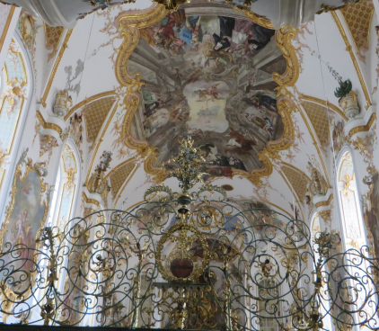
MARIA HILF | CONGREGATION HALL | SCHOOL CHURCH

